# DVD Rental Analytics

**Overview:**

A DVD rental database is a structured collection of data designed to manage and track information related to a DVD rental business. This database is crucial for efficiently managing inventory, customer information, rental transactions, and other aspects of the rental business. Below is an overview of the key components and tables you might find in a typical DVD rental database

The dataset described is a comprehensive database that appears to represent a video rental store or movie rental service. It comprises multiple tables, each representing different entities and their relationships. Taking a closer look at the key components of the dataset:

**Table Explanations**

**Actor Table**

The actor table lists information for all the actors, including first name and last name of actors.

**Address Table**

The address table contains address information for customers, staff, and stores.

**Category Table**

The category table lists the categories that can be assigned to films.

**City Table**

The city table contains a list of cities.

**Country Table**

The country table contains a list of countries or regions.

**Customer Table**

The customer table contains a list of all customers.

**Film Table**

The film table lists all the films that may be in stock in the store.

**Film_text Table**

The content of the film_text table is kept in synchrony with the film table by means of triggers on the film table INSERT, UPDATE, and DELETE operations.

**Film_actor Table**

The film_actor table is used to support many-to-many relationships between films and actors.

**Film_category Table**

The film_category table is used to support many-to-many relationships between films and categories.

**Inventory Table**

A row in the inventory table represents a copy of a given film in a given store.

**Language Table**

The language table lists all possible values for the film language and original language.

**Payment Table**

The payment table records every payment made by the customer, including information such as the amount and rent paid.

**Rental Table**

The rental table contains a row for each rental of each inventory item, which contains information about who rented what, when it rented it, and when it was returned.

**Staff Table**

The staff table lists all staff information, including email addresses, login information, and pictures.

**Store Table**

The store table lists all stores in the system.

**Objective:**

The objective of a DVD rental database is to efficiently and accurately manage all aspects of a DVD rental business. This includes tracking inventory, customer information, rental transactions, payments, staff management, and more.

**Significance:**

The significance of a DVD rental database in a movie rental business cannot be overstated. Such a database plays a crucial role in various aspects of the business, contributing to its efficiency, customer satisfaction, and overall success.

**Data Dictionary:**

Data dictionary is a comprehensive document that provides detailed information about the data elements (fields or attributes) used in a database or data management system. It serves as a reference guide for understanding the structure, meaning, and characteristics of the data stored in the database.

**ER Diagram:** 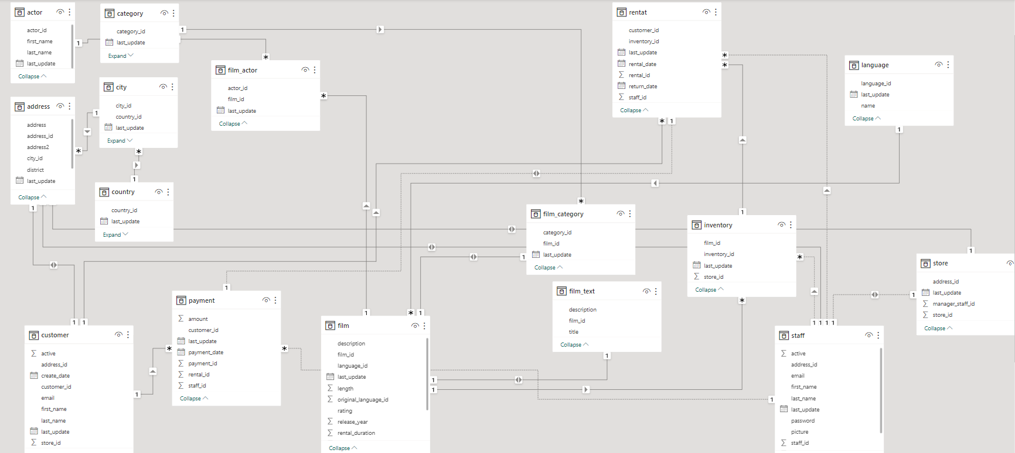

**Steps To connect to data:**

Connecting to data in a database typically involves several steps, especially when using database management systems like SQL Server, MySQL, Oracle, or others. Below are the general steps to connect to data in a database:

**1. Identify the Database:**

* Determine the database system you want to connect to. This may be a local database, a remote database server, or a cloud-based database service.

**2. Gather Connection Information:**

* Collect the necessary connection information, including:
  + **Hostname or IP Address:** The address of the database server.
  + **Port:** The port number used for the database connection (default port numbers are common for specific database systems).
  + **Database Name:** The name of the specific database you want to access.
  + **Username and Password:** Credentials to authenticate and authorize your access to the database.
  + **Authentication Method:** Identify whether the database requires specific authentication methods, such as username/password, integrated Windows authentication, or others.
  + **SSL/TLS (Secure Connection):** Determine if the database connection requires secure communication via SSL/TLS.

**3. Choose a Database Client:**

* Select a database client or tool to connect to the database. Popular choices include:
  + **SQL Server Management Studio (SSMS)** for Microsoft SQL Server.
  + **MySQL Workbench** for MySQL.
  + **Oracle SQL Developer** for Oracle Database.
  + **pgAdmin** for PostgreSQL.
  + **DBeaver** as a cross-platform, multi-database tool.

**4. Install and Configure the Database Client:**

* If you haven't already, download and install the selected database client on your local machine or the server where you plan to run it.

**5. Launch the Database Client:**

* Open the database client application.

**6. Create a New Database Connection:**

* Use the client's interface to create a new database connection. This typically involves providing the connection details you gathered in step 2.

**7. Test the Connection:**

* Most database clients offer a "Test Connection" or "Connect" button to verify that the connection details are correct and you can establish a connection to the database.

**8. Connect to the Database:**

* Once the connection is tested and successful, initiate the connection to the database by clicking "Connect" or a similar button in the client application.

**9. Access and Interact with the Database:**

* After successfully connecting, you can start interacting with the database. This may involve running SQL queries, managing database objects, or performing data operations.

**10. Disconnect and Close:** - When you're done working with the database, remember to disconnect or close the connection to release resources and ensure data integrity.

**11. Secure Credentials:** - Always take precautions to secure your credentials and connection information, especially if you're working with sensitive data. Avoid hardcoding credentials in your code or scripts.

**12. Maintain and Monitor:** - Regularly monitor database connections, performance, and resource usage to ensure the database remains efficient and secure.

These steps provide a general framework for connecting to data in a database. The specific steps and details may vary depending on the database system and the database client you are using. It's essential to follow best practices for database security and ensure that your connections are properly configured to meet your application's requirements.

**Problem Statements with solutions and insights:**

There are several problem statements commonly encountered in a DVD rental business, along with potential solutions and insights that can help address these challenges:

**Problem Statement 1: Inventory Management** Problem: Managing inventory efficiently to ensure that customers can access the movies they want, avoid stockouts, and prevent overstocking. Solution: Implement an inventory tracking system that monitors movie quantities in real-time. Use historical rental data and demand forecasting to optimize inventory levels.

**Insight:** Data-driven inventory management reduces costs, enhances customer satisfaction, and prevents revenue loss due to stockouts.

**Problem Statement 2: Customer Retention** Problem: Ensuring customers remain loyal to your rental service and continue renting DVDs. Solution: Implement a customer loyalty program with rewards, discounts, and personalized recommendations based on rental history and preferences.

**Insight:** Loyal customers are more likely to rent frequently and generate consistent revenue.

**Problem Statement 3: Late Returns and Late Fees** Problem: Dealing with late returns, managing late fees, and maintaining a fair rental policy. Solution: Set clear rental terms and due dates. Implement automated reminders via email or SMS to prompt customers to return DVDs on time.

**Insight:** Effective communication and reminder systems can reduce late returns and improve customer satisfaction.

**Problem Statement 4: Pricing Strategy** Problem: Determining the right pricing strategy to maximize revenue while remaining competitive. Solution: Analyze rental data to understand price elasticity. Experiment with pricing tiers, promotions, and bundling options.

**Insight:** Data analysis helps identify optimal pricing strategies for different customer segments and movie categories.

**Conclusion:**

In conclusion, managing a DVD rental business involves a complex interplay of inventory management, customer service, pricing strategies, and data-driven decision-making. By leveraging technology and data analysis, businesses in this industry can thrive and adapt to changing customer preferences and market conditions.

Efficient inventory management ensures that customers have access to their desired movies while minimizing costs and preventing stockouts. Customer retention strategies, including loyalty programs and personalized recommendations, foster long-term customer relationships and repeat business.

In today's digital age, a successful DVD rental business must embrace technology, data analytics, and customer-centric strategies to remain competitive and provide an exceptional rental experience. By addressing these challenges and opportunities, businesses can thrive in the ever-evolving entertainment landscape